Mockito Exercises

Exercise 1: Mocking and Stubbing

MyService.java

public class MyService {
private final ExternalApi api;

public MyService(ExternalApi api) {
this.api = api;
}

public String fetchData() {
return api.getData();
}
}

MyServiceTest.java

import org.junit.jupiter.api.Test;
import static org.junit.jupiter.api.Assertions.assertEquals;
import static org.mockito.Mockito.*;

public class MyServiceTest {

@Test
public void testFetchData_returnsMockData() {
ExternalApi mockApi = mock(ExternalApi.class);
when(mockApi.getData()).thenReturn("Mock Data");

MyService service = new MyService(mockApi);
String result = service.fetchData();

assertEquals("Mock Data", result);
}
}

OUTPUT:

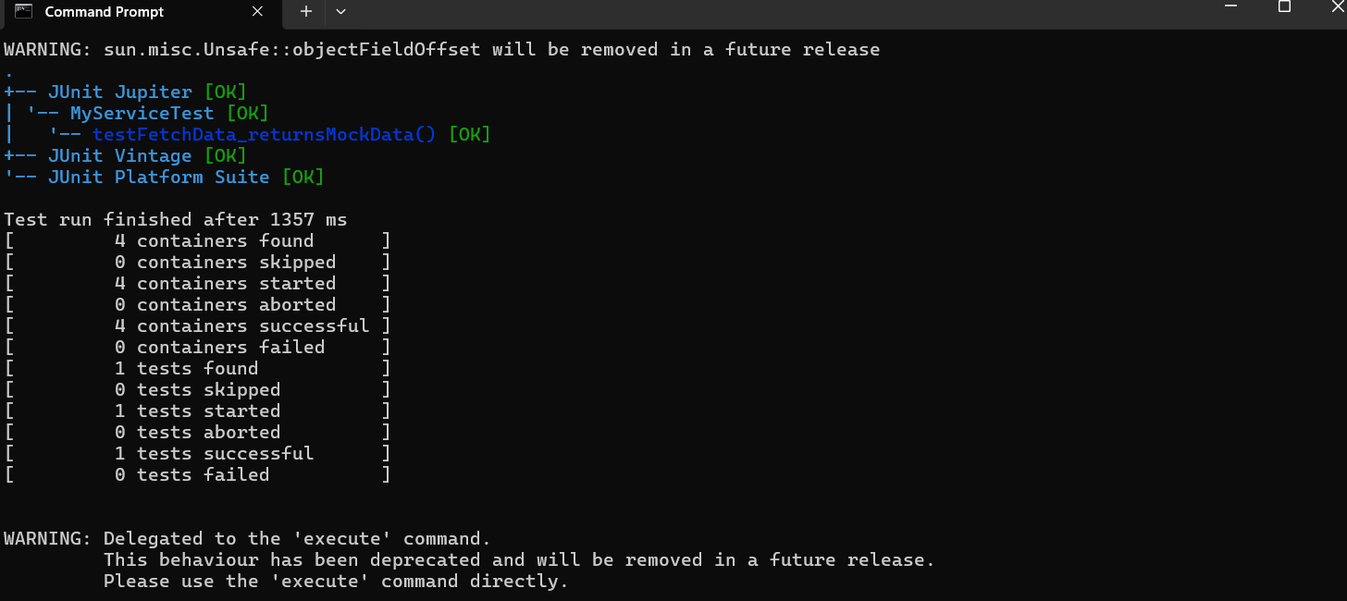

======================================================================

Exercise 2: Verifying Interactions

MyService.java

public class MyService {
private ExternalApi api;

public MyService(ExternalApi api) {
this.api = api;
}

public void fetchData() {
api.getData();
}
}

MyServiceTest.java(Argument Verification)

import static org.mockito.Mockito.*;
import org.junit.jupiter.api.Test;

public class MyServiceTest {

@Test
public void testVerifyArguments() {
ExternalApi mockApi = mock(ExternalApi.class);
MyService service = new MyService(mockApi);

service.fetchData();

verify(mockApi).getData("user123", 10);
}
}

OUTPUT:





